Children’s Art Exhibition 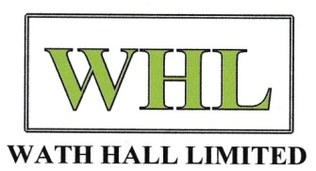
Saturday 8th July at 10am-4pm
Wath Hall, Church Street S63 7RE
This will be a wonderful display of local children’s artwork and a brand new venture for Wath Hall Limited.
Children can bring any picture they have created to the Hall on Saturday 1st July 10am -12md.
The picture needs to have the artists name, age and school on the back with the title of the piece.
There are also prizes for the best picture of Wath Hall which will be presented by the Mayor and her consort at 3.30pm on the day.
Adult entry to the exhibition is £1 as a suggested donation to the Wath Hall charity. Children’s art entries and Children’s entry to the hall are all free of charge. There will be refreshments, tours of the hall and a raffle too. So please come along and support your community.
Contact Ray Lewis atbutterflygallery@mail.com for further details.

